Annex C: Governance Assurance Statement

The LEP Chair and Chief Executive should here provide a brief formal assurance statement on the status of governance and transparency. This should include any overview and scrutiny function undertaken by the Accountable Body. This should be sent to the Assurance Team via localgrowthassurance@levellingup.gov.uk, copying the BEIS Area Lead, by 19 January 2023. This statement should also be published on the LEP’s website by 28 February 2022 with confirmation sent to the email address above. (max 500 words)
The S151 officer is consulted on all LEP Board decisions, where there may be a conflict of interest this is declared and the Board seeks independent opinion in these circumstances.

All decisions and actions are reviewed to ensure they are compliant with the assurance framework which is posted on the LEP website .

Scrutiny
The LEP has a Scrutiny Committee comprised of one member from each of the County Council, Unitary Authoritiers and District Authorities (15 members in total). It meets a minimum of twice per year and the LEP is currently seeking a private sector board Director. In the interim, the de facto Chair is a nominated and agreed Local Authority Member. These arrangements are set out in the Local Assurance Framework and on the LEP's website. The LEP is willing to attend any Local Authority Scrutiny Arrangements if requested. Terms of Reference set out the role and responsibilities of te Scrutiny Committee, its membership and ways of working. At the first Scrutiny Committee meeting, the Members were give an overview of all LEP activity to provide context and help them to determine future items for scrutiny.

Signed: 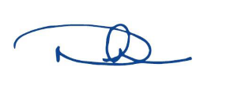
Name: Debbie Francis OBE
Position: Chair
Date: 27/01/23

Signed:
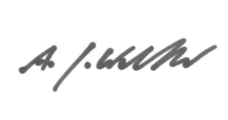
Name: Andy Walker
Position: Chief Executive Officer
Date: 27/01/23

