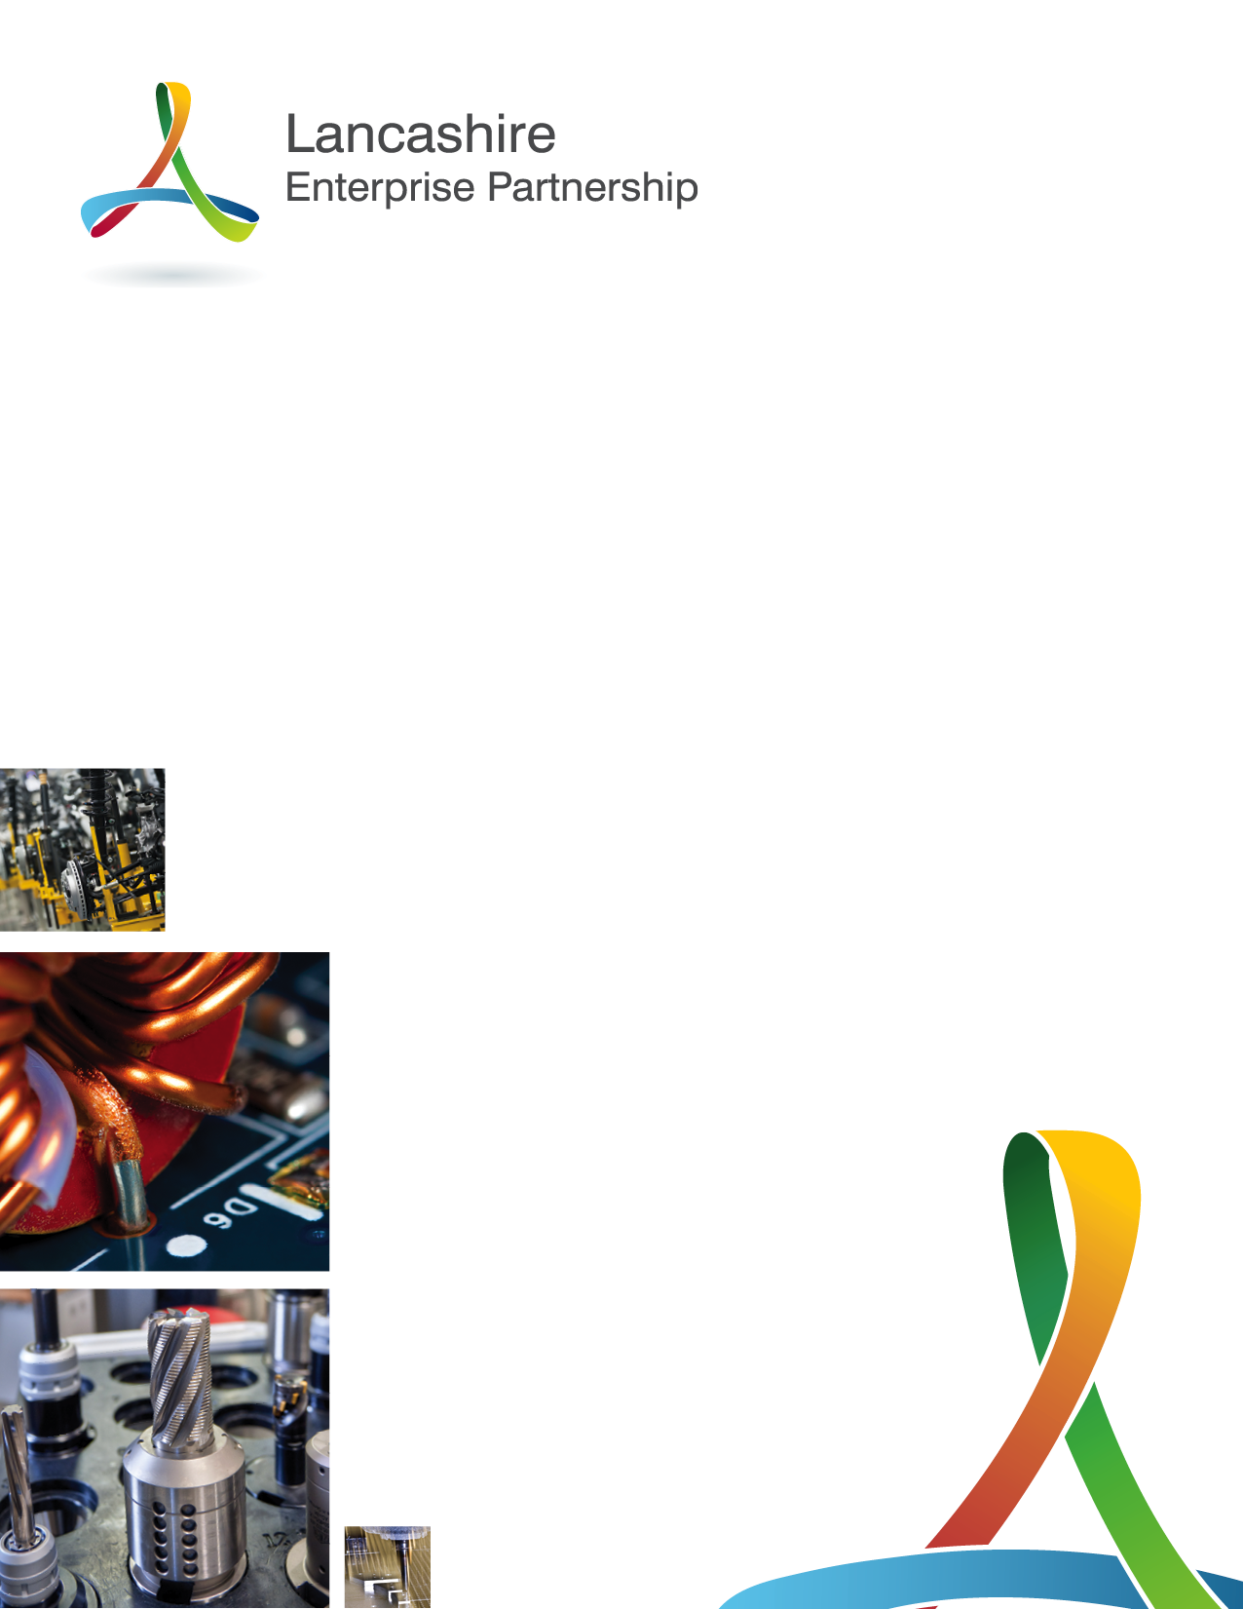

LEP Director Opportunities
Candidate Information Pack

Foreword
Steve Fogg, Chair of the Lancashire Enterprise Partnership
Firstly, I would like to take this opportunity to thank you for taking the time to consider applying for one of the Non-Executive Director positions on the Board of the Lancashire Enterprise Partnership (LEP).
I took on the role of Chair of the LEP in September last year and whilst I have been on a very steep learning curve, it has certainly been an interesting and worthwhile experience. Lancashire is a very complex, diverse and interesting county with a strong heritage set within a mix of coastal, rural and urban areas, each with their own challenges but with immense potential. As a partnership charged with driving economic growth for the county, it is our responsibility to ensure Lancashire realises its full potential and to do so, we need a board which is made up of individuals who are passionate and committed to making a difference.
Our board is made up of individuals from a variety of backgrounds, each with their own unique expertise and skills which when combined offer unrivalled industry expertise, insight and leadership. All of which is crucial if we are to realise our growth ambitions and position Lancashire as a great place to invest, do business, live and visit. These current board vacancies are looking to enhance an already exceptional skills base and whilst we are particularly interested in receiving applications from senior leaders with digital transformation skills, we are equally looking for members who will play an enthusiastic and active role in transforming the Lancashire economy.
Just as the county is diverse in its component parts, we are also looking for a board which is equally diverse and is reflective of the people and businesses it is there to represent. The board is committed to developing a culture which not only embraces change, but embraces difference and we are seeking to rebalance its membership during this phase of recruitment.
Being a Non-Executive Director of the LEP will not be without its challenges. The advent of Covid-19 has brought with it unprecedented levels of pressure on our businesses as they fight for survival; and we are doing everything within our power to help them stabilise as they emerge from the pandemic. However it will be some time before we know the full extent of the economic impact, and we have to accept that some businesses operating within certain sectors may take quite some time before they return to pre Covid-19 levels of profitability and we will likely be dealing with a different economic landscape. But with the right mix of members on the board, I am confident the Lancashire Enterprise Partnership will be able to rise to the challenge and provide the leadership to enable Lancashire to bounce-back and build back better to realise its full potential.
So whilst the role may be challenging, and at times even frustrating, it will never be boring and it will certainly be rewarding. So if you feel you have the expertise, along with a positive can-do attitude and a commitment to driving transformational change in Lancashire, I will look forward to receiving your initial Expression of Interest form.
Regards
Steve Fogg, Chair

Background and Next Steps

The Lancashire Enterprise Partnership is a private sector led body, chaired by Steve Fogg, with a Board of 15 Directors drawn from business, local government and university sectors.

It is one of 38 Local Enterprise Partnerships in England established by local partners and Government.

The LEP is working with local and national partners to improve the growth prospects of businesses and residents across Lancashire. To this end, since its inception in 2011, the LEP has achieved significant success by establishing a Strategic Economic Plan (SEP) which has enabled Lancashire to secure its largest ever growth programme valued at nearly £1 billion. The growth programme comprises almost 50 strategic developments through the Lancashire Growth Deal, business growth, innovation, skills, infrastructure and place-making initiatives.

The LEP is also playing an active leadership role in the development of the Northern Powerhouse and the work of Transport for the North, while engaging with neighbouring city-regions on shared priorities to ensure Lancashire is able to capitalise on its existing strengths and take advantage from emerging opportunities through increased collaboration.

Until recently, the LEP Board was focussed on developing a Local Industrial Strategy for Lancashire which aims to improve productivity and stimulate inclusive growth outcomes throughout the county.

However the advent of Covid-19 has resulted in a short to medium term refocus of LEP activities as we look at ways in which we are able to minimise the threat of long-term repercussions for Lancashire businesses which have been adversely impacted by the lockdown restrictions. Different sectors of the economy will have been affected in different ways and recover at varying rates. The LEP is working hard with partners to obtain sectoral intelligence and the interventions required to reduce the speed with which recovery takes place.

More information about the LEP including its Achievements, Annual Report, Business Plan and Growth Deal Progress Summary can be accessed via the LEP website here: www.lancashirelep.co.uk

You can also access the LEP's Strategic Economic Plan here: http://www.lancashirelep.co.uk/about-us/what-we-do.aspx

The LEP is a private limited company that is owned by Lancashire County Council and Blackpool Council.
The Articles of Association for the company can be accessed here: https://lancashirelep.co.uk/wp-content/uploads/2019/05/Articles-of-association-29.03.2019.pdf

The LEP is governed by an Assurance Framework that fully complies with national Government guidance. All LEP Directors are required to abide by the Assurance Framework and the Code of Conduct for Board Members, which includes the Nolan Principles of Public Life. The LEP's Assurance Framework and other polices can be accessed here: https://lancashirelep.co.uk/wp-content/uploads/2019/11/LEP-Assurance-Framework-December-2019-V.01.pdf

The LEP Board meets a minimum of 4 times a year, with additional meetings as required. Board meetings usually take place around the county. The Board is also supported by sub-committees on which Directors agree to serve. These sub-committees usually meet a minimum of 4 times a year. More details on the LEP's governance and decision-making arrangements can be found in the Local Assurance Framework in the previous link.

LEP Directors receive no remuneration for their services however reasonable expenses will be paid for undertaking LEP related activities.

Should you wish to express an interest in being considered as a LEP Director, please complete the Expression of Interest form.

If you would like an informal discussion with the Chair, please arrange via his PA: Victoria.pemberton@lancashirelep.co.uk

Expression of interest forms should be returned to: Victoria.pemberton@lancashirelep.co.uk

The closing date for Expressions of Interest is 17th July 2020.

Interview dates are to be confirmed.

Lancashire Enterprise Partnership
Board Director Opportunity
Expression of Interest Form
Name
Name of Company/Organisation
Position in Company/Organisation
Contact Address

Telephone Number & Email
Personal Profile

Business Profile

Statement of Interest

Please submit completed forms to: Victoria.pemberton@lancashirelep.co.uk
Deadline for Expressions of Interest is 17th July 2020

